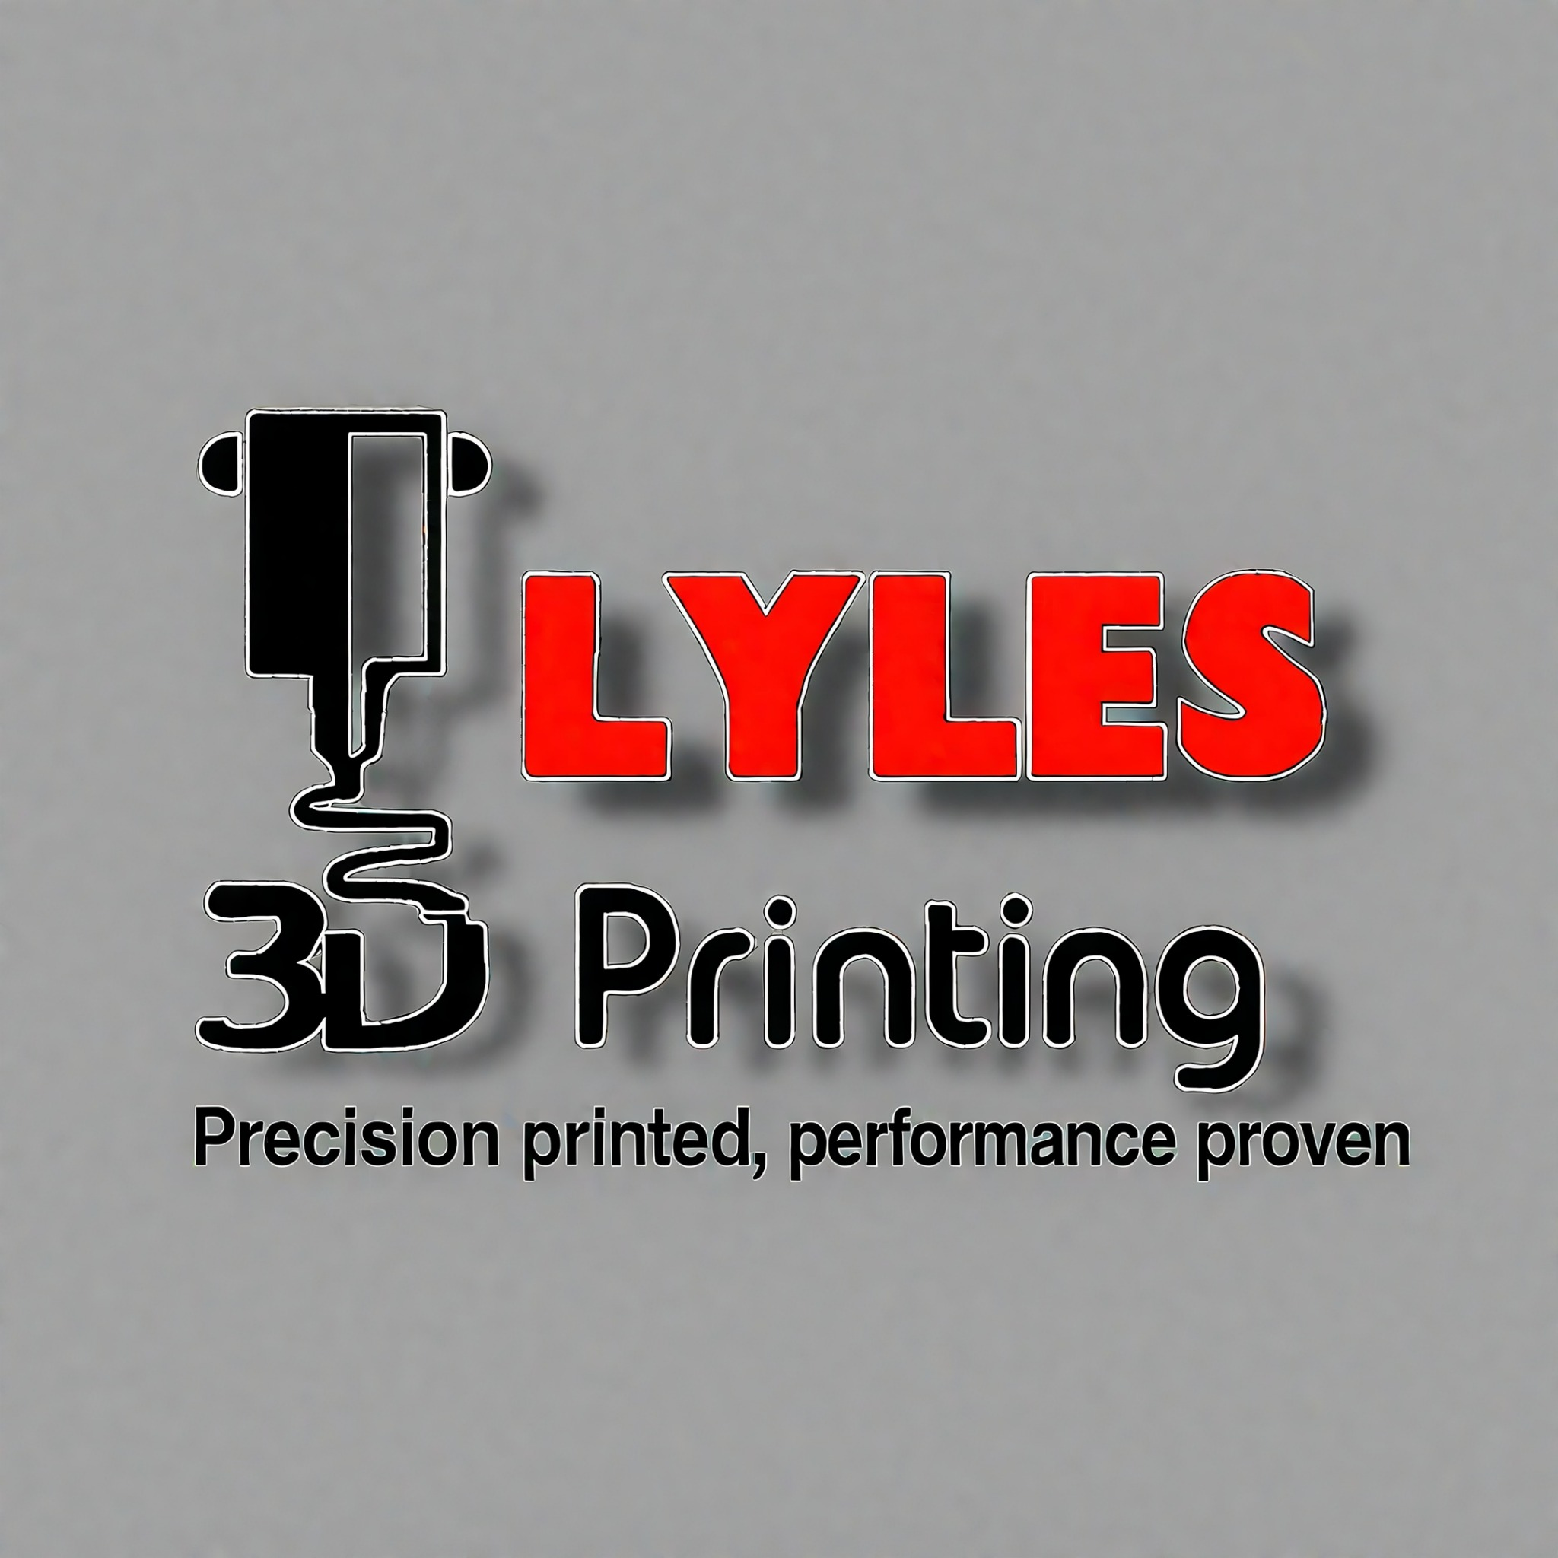
From the Marine Corps to Additive Manufacturing Innovation
By Daniel Lyles
9/28/2025

A Foundation in Service and Engineering
My professional journey began in the United States Marine Corps, where I served for thirteen years and rose to the rank of Gunnery Sergeant. During that time, I spent nearly half my career as a Combat Engineer (1371) before transitioning into air defense electronics. This dual background gave me both the hands-on construction and fabrication skills of an engineer and the technical expertise of an electronics technician.
As a Combat Engineer, I learned to be a jack of all trades—operating heavy equipment, building fortifications, and carrying out demolition and construction tasks under austere conditions. Precision measurements and critical thinking were essential. Whether building survivability positions, clearing routes, or fabricating under pressure, I was required to ensure accuracy and safety in environments where mistakes could not be afforded.
Later, as an Air Defense Electronics Technician and Maintenance Chief, I was responsible for supervising, training, and leading more than thirty Marines in the upkeep and readiness of advanced electronic systems. Both engineering and electronics demanded the same traits: discipline, adaptability, and problem-solving. These experiences instilled in me a lifelong commitment to precision and innovation.
Unfortunately, my military career ended earlier than I expected when I was medically retired. Leaving behind the Marine Corps—where I had built both a profession and an identity—was one of the most difficult challenges of my life.

Returning to School and Reforging Purpose
Determined to keep building my skills, I returned to school to pursue an Associate of Applied Science. I focused on design/ engineer coursework, computer-aided design (CAD), and additive manufacturing. Programs like Autodesk Inventor and Fusion 360 became my new “toolkit.” I approached every course the way the Marine Corps trained me—measure carefully, learn quickly, and execute with precision.
Design/Engineering education gave me a new mission. I shifted from constructing bunkers and troubleshooting radar systems to designing parts digitally, prototyping in plastic and composites, and learning how to turn concepts into working components. I found that the same mindset I had in the Corps—adapting under pressure, solving problems creatively, and working with precision—fit naturally in the world of design and manufacturing.

Family, Creativity, and a Spark of Innovation
At home, another chapter was beginning: raising kids. Like many fathers, I wanted to create, fix, and play with them. Power Wheels became the platform for that creativity. What began as weekend tinkering—replacing tires, reinforcing parts, and modifying motors—quickly grew into something bigger.
Soon I realized these projects were more than toys. They were engineering challenges: building gearboxes that could handle more torque, designing wheels that provided better traction, or making the appearance car show ready with body modifications, paint, and aftermarket details. Combining my engineering background from the Marine Corps, my CAD and additive manufacturing education, and my role as a father, I turned play into innovation.

From Playtime to Performance Engineering
What started as family fun evolved into Lyles3DPrinting, my independent design and additive manufacturing business. Today, I design and 3D print every single day—constantly refining, testing, and innovating. I push myself to learn something new several times a week, whether it’s experimenting with advanced materials like carbon-fiber composites, refining print tolerances, or testing post-processing techniques such as annealing for added strength.
My parts are no longer just modifications for my kids’ cars; they are high-performance aftermarket components used in Power Wheels drag racing and other automotive-inspired builds. I apply engineering workflows—solid modeling, surface design, mesh repair, and freeform sculpting—to produce parts that are stronger, lighter, and more precise than stock components.
Through this process, I’ve discovered a niche where family, engineering, and creativity intersect. The same discipline that drove me in the Marine Corps now drives me to deliver aftermarket performance parts that help others push limits, race faster, and innovate alongside me.

The Ongoing Mission
My story is one of transformation and resilience. From building and engineering in the Marine Corps to studying design and creating as an entrepreneur, I have continued to evolve. Being medically retired did not end my mission—it simply redirected it.
Today, my battlefield is additive manufacturing. Every day, I design, print, test, and improve. Every week, I learn something new. I carry forward the traits the Corps instilled in me—discipline, adaptability, and precision—and combine them with my engineering skills and entrepreneurial drive.
What began as service and sacrifice became creativity and innovation. My work now stands at the intersection of design, family, and performance engineering—a place where I can keep building, keep learning, and keep moving forward.

